Phase 6
Project Documentation

Project Documentation Format

1. Introduction
Project Title: Virtual Agent–Driven SLA Breach Awareness & Justification System
Team Members:
S.No | Name | Email | College
1 | Polamarasetti Sravanthi | polamsettiramu@gmail.com | MVGR
2 | Malla Rama Krishna | 23331a05a9@mvgrce.edu.in | MVGR

2. Project Overview
Purpose: To proactively detect SLA breach risk, enforce breach accountability through mandatory justification, guide assignees via a conversational Virtual Agent, and give leadership real-time visibility into SLA performance — all without custom code.
Features: Automated SLA risk detection, Virtual Agent guided acknowledgement, mandatory breach justification (UI Policy), role-based access control (ACL), an executive Performance Analytics dashboard, configurable per-SLA thresholds, and manager escalation for unacknowledged risk.

3. Architecture
Platform (in place of a traditional frontend/backend/database split, this solution runs entirely natively within ServiceNow):
● "Frontend" equivalent: ServiceNow Service Portal / Now Experience UI and the Virtual Agent chat widget, through which assignees view alerts and interact with governance prompts.
● "Backend" equivalent: Flow Designer flows/subflows (SLA Risk Monitor), UI Policies, and Business Rules implementing all process logic declaratively.
● "Database" equivalent: Native ServiceNow platform tables — Task/Incident, SLA definitions, and the system audit table (sys_audit) — storing all governance and justification data.
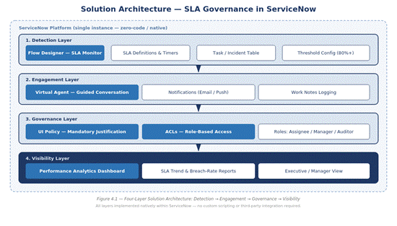
Figure 6.1 — Platform Architecture

4. Setup Instructions
Prerequisites: A ServiceNow instance (sub-production/developer instance recommended) with admin access, Flow Designer, Virtual Agent, and Performance Analytics plugins active.
Installation: Import the exported Update Set containing the SLA Risk Monitor flow, UI Policies, ACLs, and Virtual Agent topic; commit to the target instance; configure SLA threshold values and role assignments for your environment.
● Step 1: Retrieve Update Set XML from the source instance or repository.
● Step 2: Navigate to System Update Sets > Retrieved Update Sets and import the XML.
● Step 3: Preview and commit the Update Set, resolving any collisions with existing configuration.
● Step 4: Configure SLA threshold values under the SLA Risk Monitor flow's input variables.
● Step 5: Assign the Assignee, Manager, and Auditor roles to the appropriate user groups.

5. Folder / Configuration Structure
● Flow Designer: SLA Risk Monitor flow and supporting subflows
● UI Policies: Breach justification enforcement rules on the Incident/Task form
● Access Control: ACL rules restricting SLA-field edits to the assignee role
● Virtual Agent: Guided-conversation topic for SLA-risk acknowledgement
● Reports/Dashboards: Performance Analytics widgets for the executive dashboard

6. Running the Application
No local build or server start is required — the solution runs live within the ServiceNow instance once the Update Set is committed and SLA definitions/thresholds are configured. Agents interact with it directly through their existing Agent Workspace and notification channels; no separate login or application is needed.

7.. Authentication & Authorization
Authentication is handled by native ServiceNow platform login (SSO/LDAP as configured on the instance). Authorization is enforced through role-based Access Control Lists (ACLs): only the assignee role may edit SLA-critical fields, while manager and auditor roles retain read-only visibility. Justification entries become non-editable once submitted, preserving audit integrity.

8. User Interface
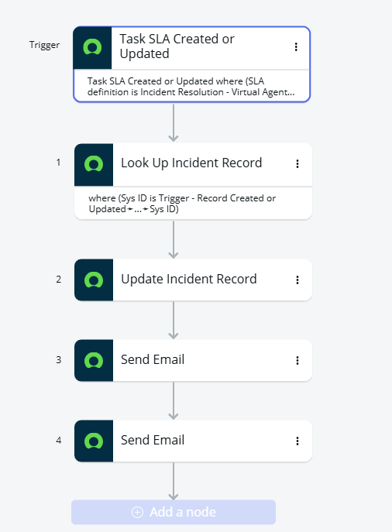

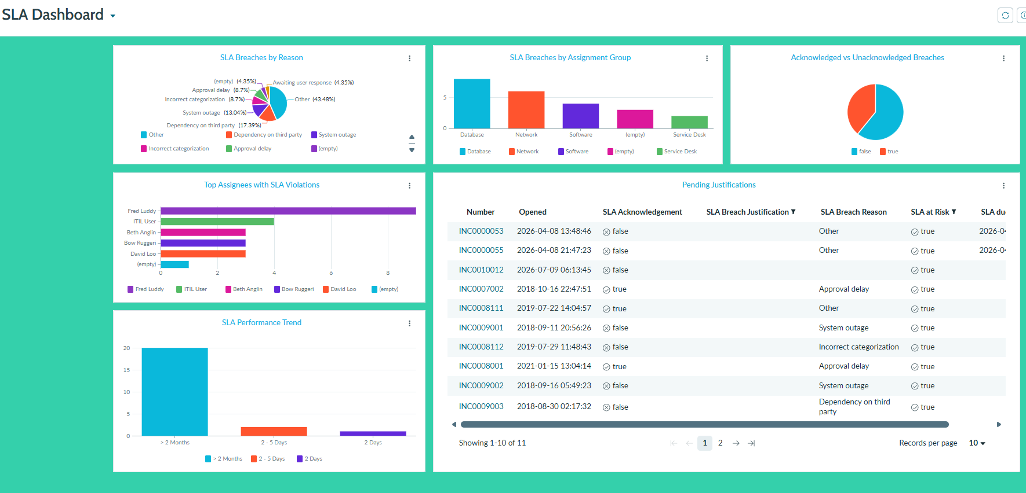

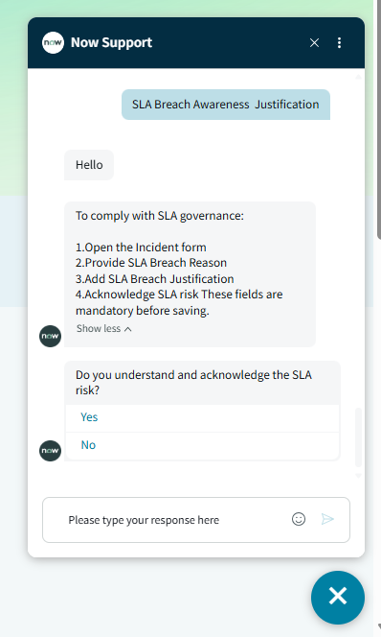

9. Testing
Testing strategy and tools are documented in full under Phase 5 — Project Development Phase (Functional & Performance Testing / UAT), covering 10 functional test cases, 5 performance metrics, and bug tracking with sign-off procedures.

10. Screenshots or Demo
Incident created:

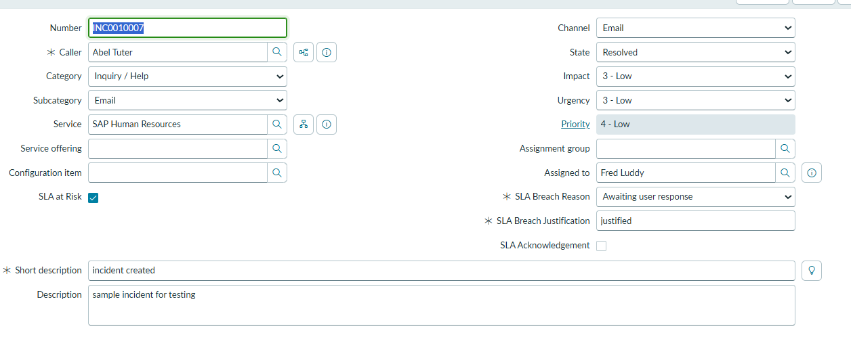
SLA Progress:

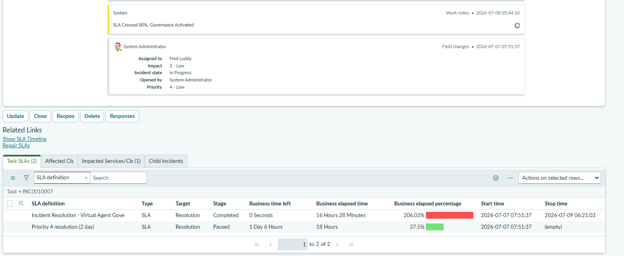
Flow Designer:

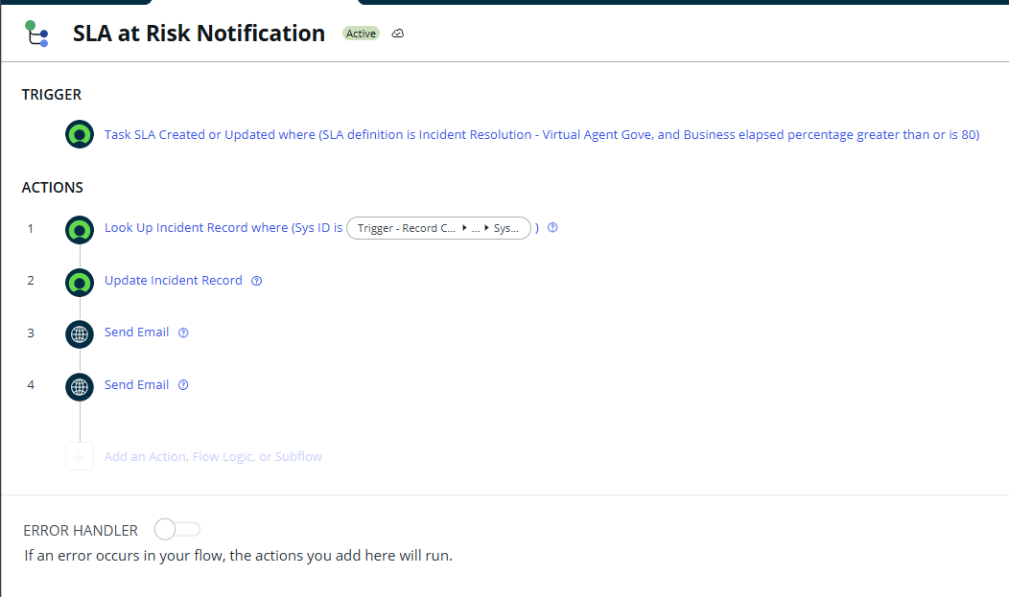

Preview Email:

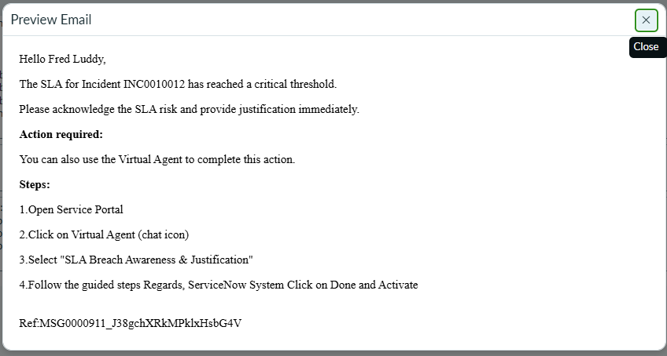

SLA Definition:

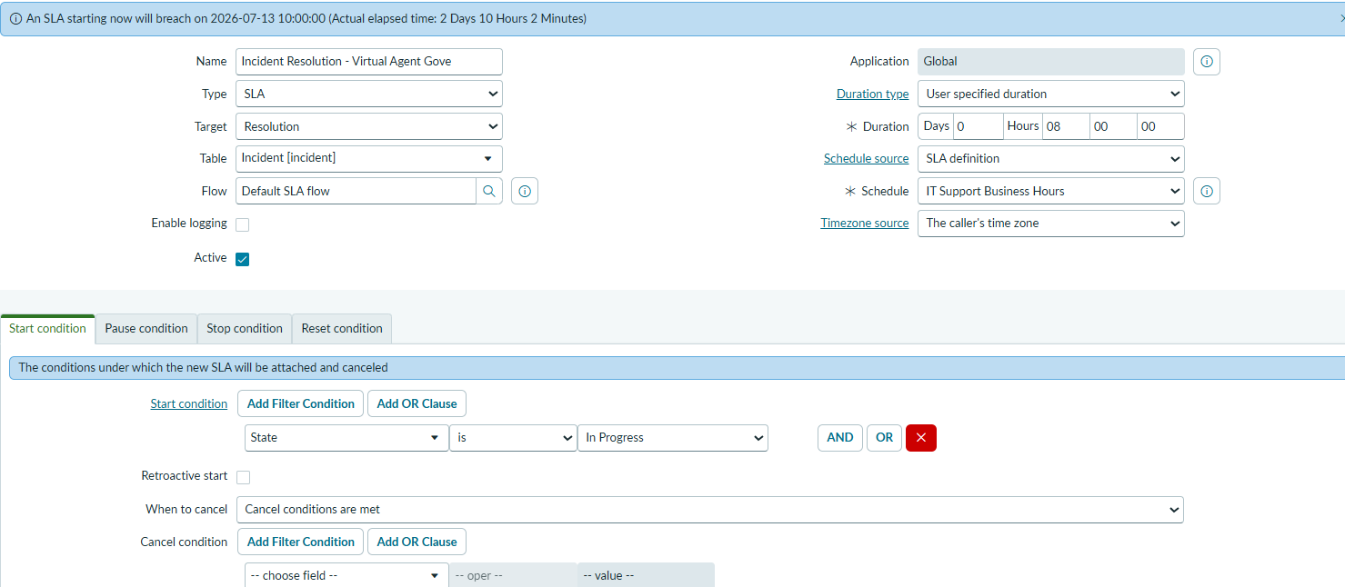

11. Future Enhancements
● Extend SLA governance beyond Incident/Task tables to HRSD, CSM, and custom applications.
● Introduce predictive SLA-breach risk scoring using ServiceNow Predictive Intelligence.
● Add manager escalation paths and automated re-assignment for high-risk SLAs.
● Expand the Virtual Agent to support proactive coaching based on historical breach patterns.
● Package the framework as a scoped application for distribution via the ServiceNow Store or as an internal accelerator template.

